

C0638 Manufacturing Custom Fields

Customisation Specifications

This document has been approved by

Steve Hardy | Sharon Standing
Business consultant | Solution owner or accountable role
Date | Date

TABLE OF CONTENTS
1.1 Description 6
1.2 Sub Function 7
1.2.1 Functional Requirement and Prerequisites 7
1.2.2 Functional Solution 7

Document Revision History
Revision | Date | Author | Remarks
1 | 06/04/2021 | S. Hardy | 1st draft

Purpose and Guideance
This document specifies how the defined functions shall be developed or how the application shall be customized to solve the business requirements.

The Solution Description defines what will be delivered. The solution is matched against the requirements described in the Requirements section.
The Delimitations describe what is explicitly not covered by this customization. Together with the Solution description, these sections delimit the extent of the functional addition agreed for implementation.

Open Issues/Decisions Required
This specification cannot be completed until the following issues/decisions have been resolved:
Issue/Decision | Responsible
Custom fields required for Shop Order processing | S. Standing

Business Requirements and References
Business requirements, references, sources and relations to other customizations are defined in Business requirement specification:
Document No | Rev | Document Name | Comments
?

Solution Description

Description
Shop orders require additional custom fields for the following:
- Concession Number: There are occasions when concessions are raised, and they need to be referenced on one or more shop orders. This custom field is required on the Shop Order header.
Event action C_0519_RESERVE_SN will check this field for a value and include it as part of the serial number if applicable.
- Default Location: The default location to receive products into stock is required by handling unit. This custom field in required on the Master Part / Handling Unit Capacity screen.
This information will then be used by event action C_0519_RESERVE_SN to update the ‘Proposed Location’ on the shop order.

Sub Function

Functional Requirement and Prerequisites
Functional Requirements
The functional requirement is to provide custom fields to hold additional key information.
Pre-requisites
None

Functional Solution
The functional solution is to provide custom fields to hold additional key information.

Custom Field 1: Concession No

This custom field is set up in the DEV environment on the Shop Order screen.

Navigator path: Manufacturing\Shop Order\Order\Shop Order

Please copy this custom field from DEV into REF.

Custom Field 2: Default Location

This custom field is set up in DEV.

Navigator path: Part Master Data\Master Part\Part
Tab: Handling Unit Capacity

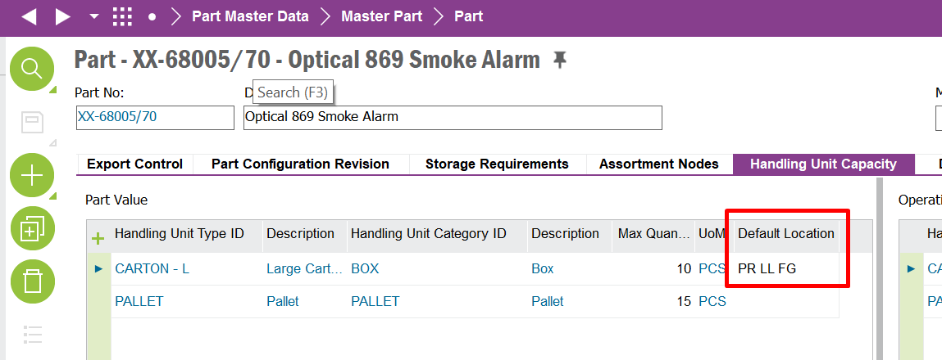

This custom field will automatically replicate on the Parts per Handling Unit screen once the custom field is added to the screen

Navigator path: Part Master Data\Master Part\Parts per Handling Unit

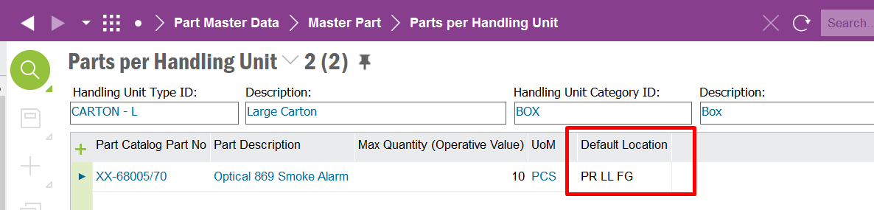

Please copy this custom field from DEV into REF but include the following:

Set a list of values against the custom field reading the Inventory Locations in IFS table WAREHOUSE_BAY_BIN.

It must only be able to save a valid location from the Inventory Locations into the Default Location custom field.

Delimitations

The configuration in this specification will be developed explicitly as written. Requests for changes in the configuration necessary to fulfil (or prepare for future fulfilment of) any requirements not explicitly described in the specification, will be considered outside the scope of this configuration.
Translations other than stated under chapter translations are not included in the scope for this specification.
Changes or extensions on Online Help (F1 Help), e-learning material or process models are excluded from this specification.

Translations
N/A
Prog Text | Translation | Window/form (optional) | Comment

Go Live Information/Upgrade Issues
N/A

Performance Considerations
N/A

Glossary/Acronyms
Commonly used IFS terms within this specification include:
Term | Explanation
LOV | List of Values. This refers to a source list of records from which to select in a form.
RMB | Right Mouse Button. Commonly used abbreviation

Delivery NOTES
Permissions granted – IFS_ALL
Package - EA_MANUFACTURING
Custom Fields
- Confession No – Shop Order Window
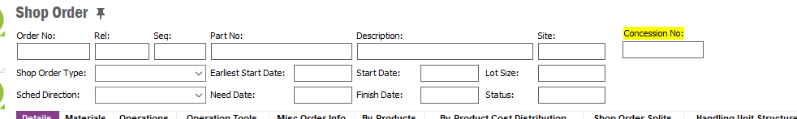
Note: If the customer field is not available on the layout, RMB, Properties, Layout and add the custom field to the layout.

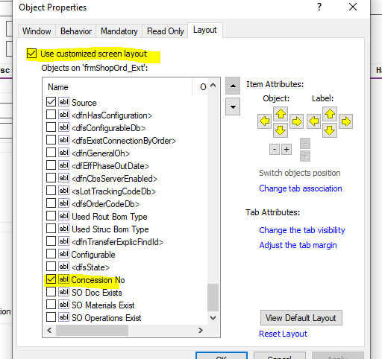

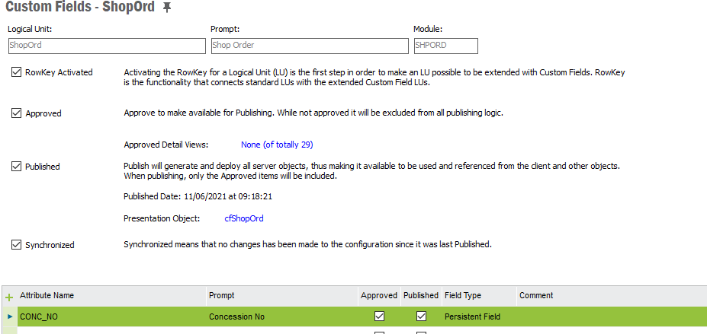
- Default Location – Part Window

If the column is not available in the layout, RMB, column chooser and add the column.
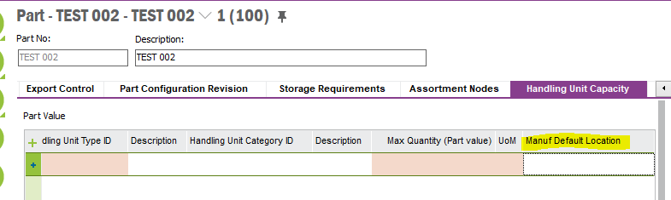

Custom Event
TO_VALIDATE_DEFAULT_LOCA events needs to be enabled.

